**Risk Management Plan:**

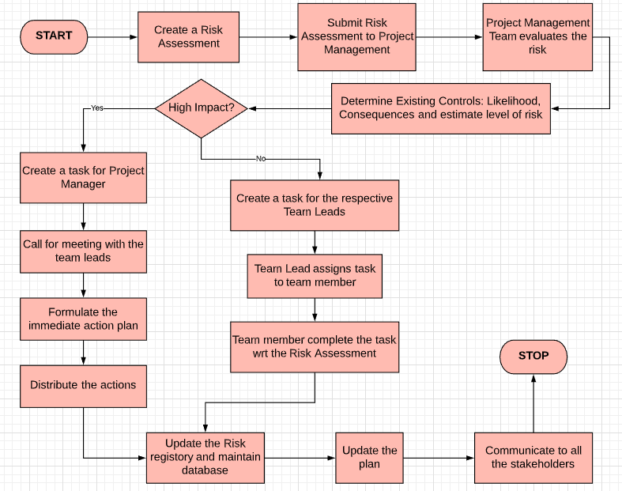

|  |  |  |
| --- | --- | --- |
| Sr No | Flowchart Element | Description |
| 1 | START | When a risk is identified, the process of Risk Management Plan will start from this point. |
| 2 | Create a Risk Assessment | Any member from different teams in the project can create a risk assessment request. For example, a developer or a tester. |
| 3 | Submit Risk Assessment to Project Management | This risk assessment is then submitted to the project management team to review. |
| 4 | Project Management Team evaluates the risk | The project management team evaluates the risk based on the information provided |
| 5 | Determine Existing Controls: Likelihood, Consequences and estimate level of risk | Risk likelihood and its consequences should be calculated in order to estimate the level of risk. Risk are categorized as high level and low level. |
| 6 | High Impact? | This classifies the flow based on the level of risk |
| 7 | Create a task for Project Manager | If it is a high-level risk, it is escalated to the project manager and a task is generated for him to investigate the risk |
| 8 | Call for meeting with the team leads | The project manager will conduct a meeting with the team leads to formulate the mitigation or contingency plan |
| 9 | Formulate the immediate action plan | The team leads and project manager develop the action plan that includes steps needed to overcome the risk |
| 10 | Distribute the actions | Communication is sent to all the stakeholders about the change being implemented. |
| 11 | Create a task for the respective Team Leads | If the risk not high level, a task for assigned to individual team leads |
| 12 | Team Lead assigns task to team member | Team leads assign the task of formulating the mitigation plan to individual team members |
| 13 | Team member complete the task wrt the Risk Assessment | Assigned Team member performs the task and closes the task. |
| 14 | Update the Risk registry and maintain database | Risk registry is updated with the identified risk for future projects and database is maintained. |
| 15 | Update the plan | Updates to the project schedule or plan are made to incorporate our risk mitigation plan. |
| 16 | Communicate to all the stakeholders | Communication is sent to all the stakeholders about the change being implemented. |
| 17 | STOP | This Risk Management Process has finished. |